**Using Open-Zeppelin Library for token transferring**

Starting Ganache-cli

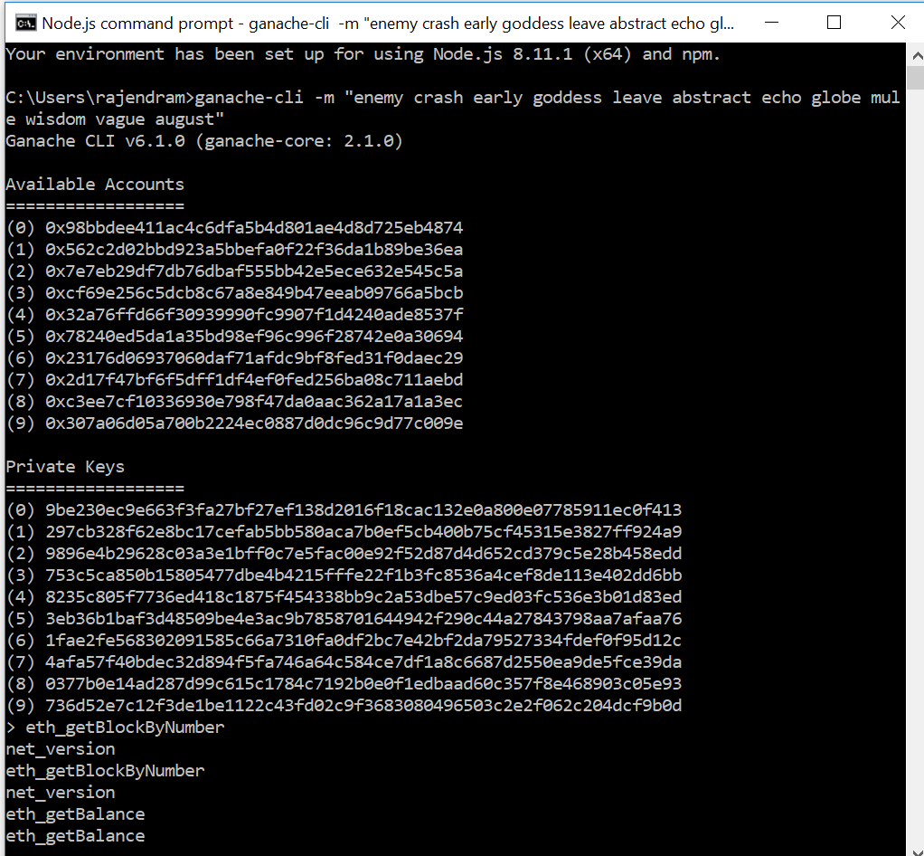

**Starting another terminal and compile, migrate and run application**

Truffle compile

Truffle.cmd migrate

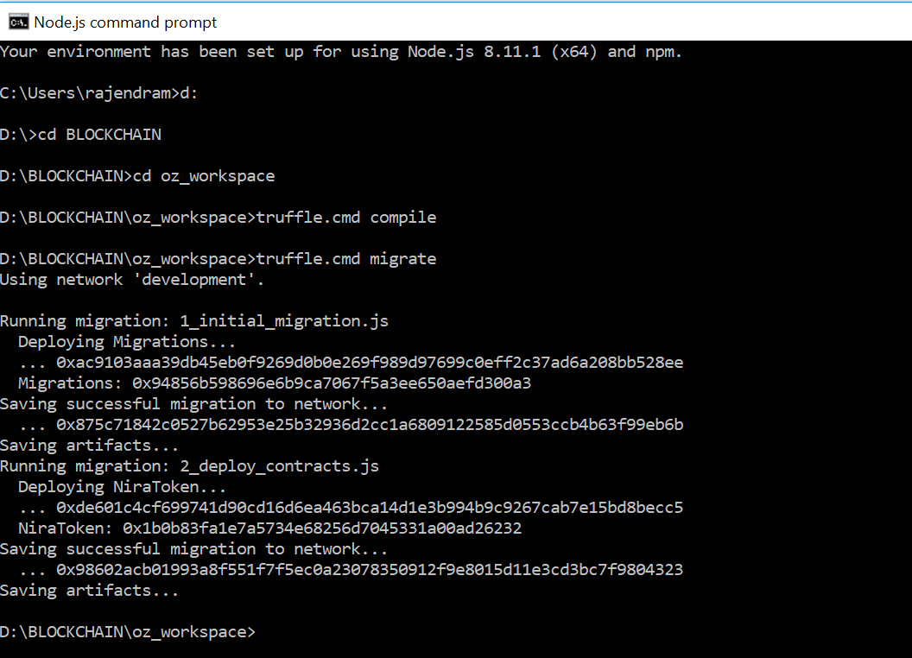

**DApps running**

npm run dev

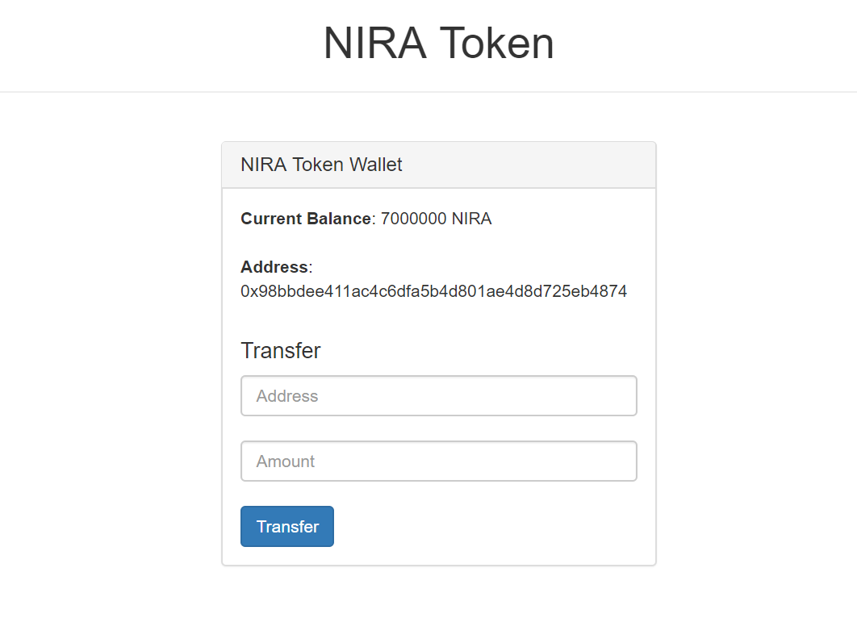

**Transfer Tokens to Ethereum Address**

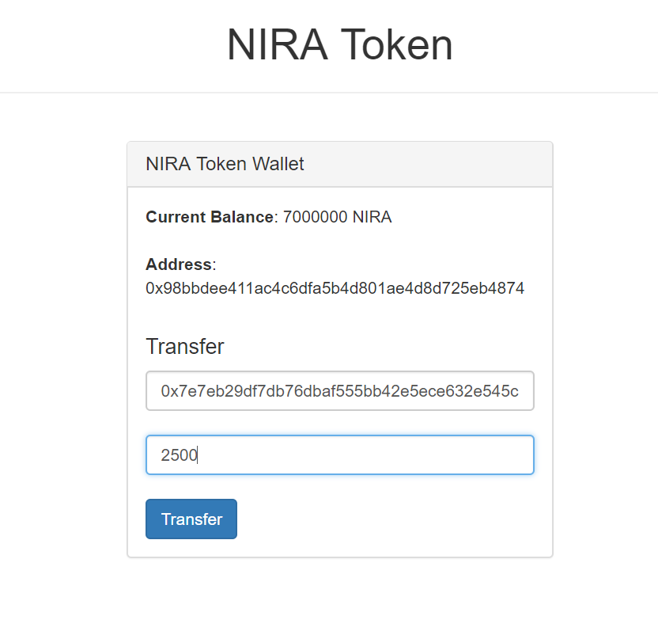

**Transferring tokens using MetaMask**

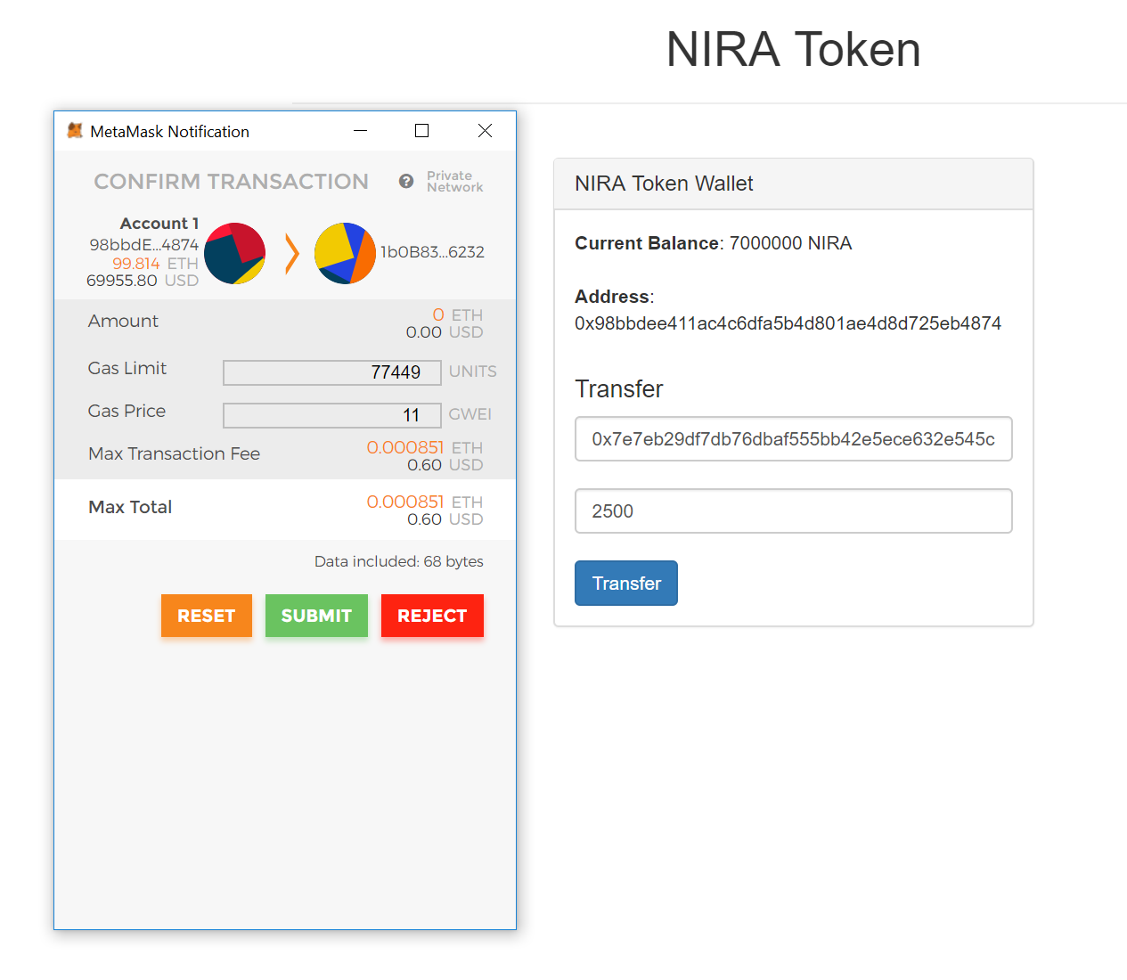

**Transfer confirmation**

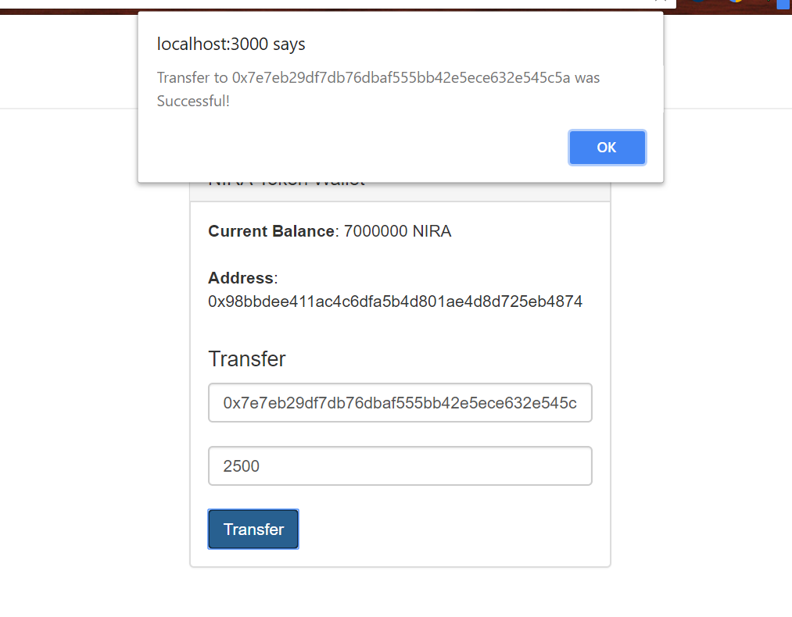

**Remaining Token Balance**

